ICT 3314

Embedded Systems

Assignment 02

Y.M.G.D.L. Yapabandara

ITT/2020/119

1381

Department of Information & Communication Technology

Faculty of Technology

Rajarata University of Sri Lanka

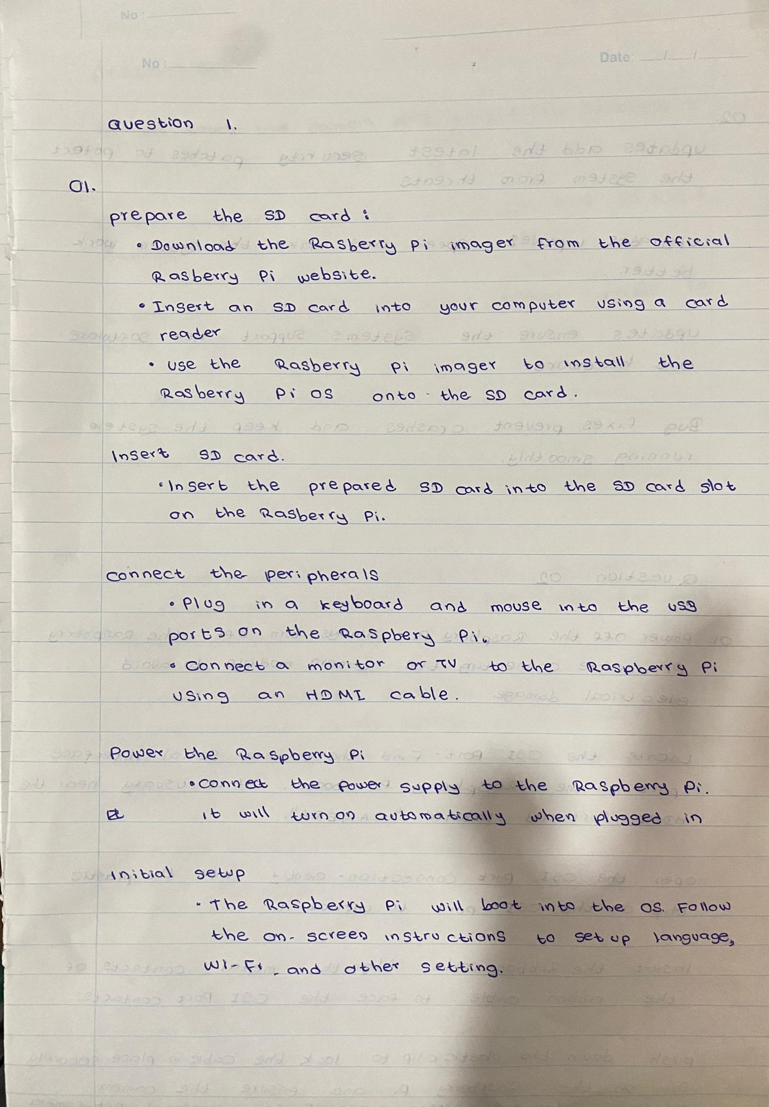**Question 1**

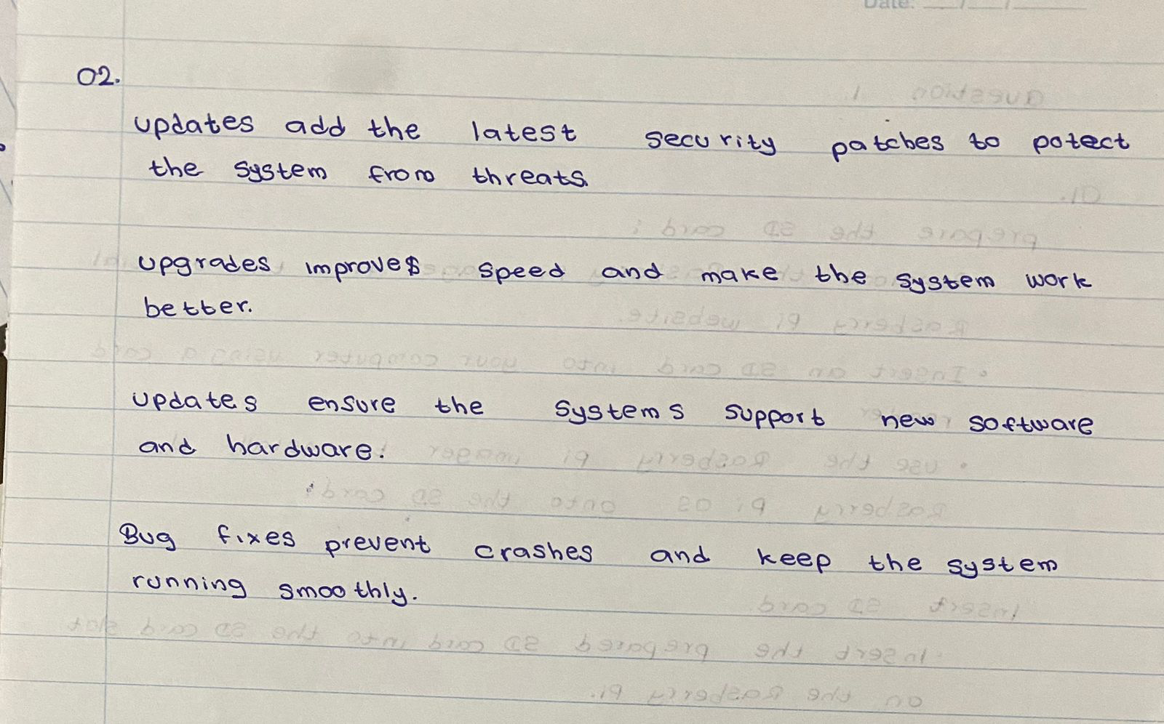

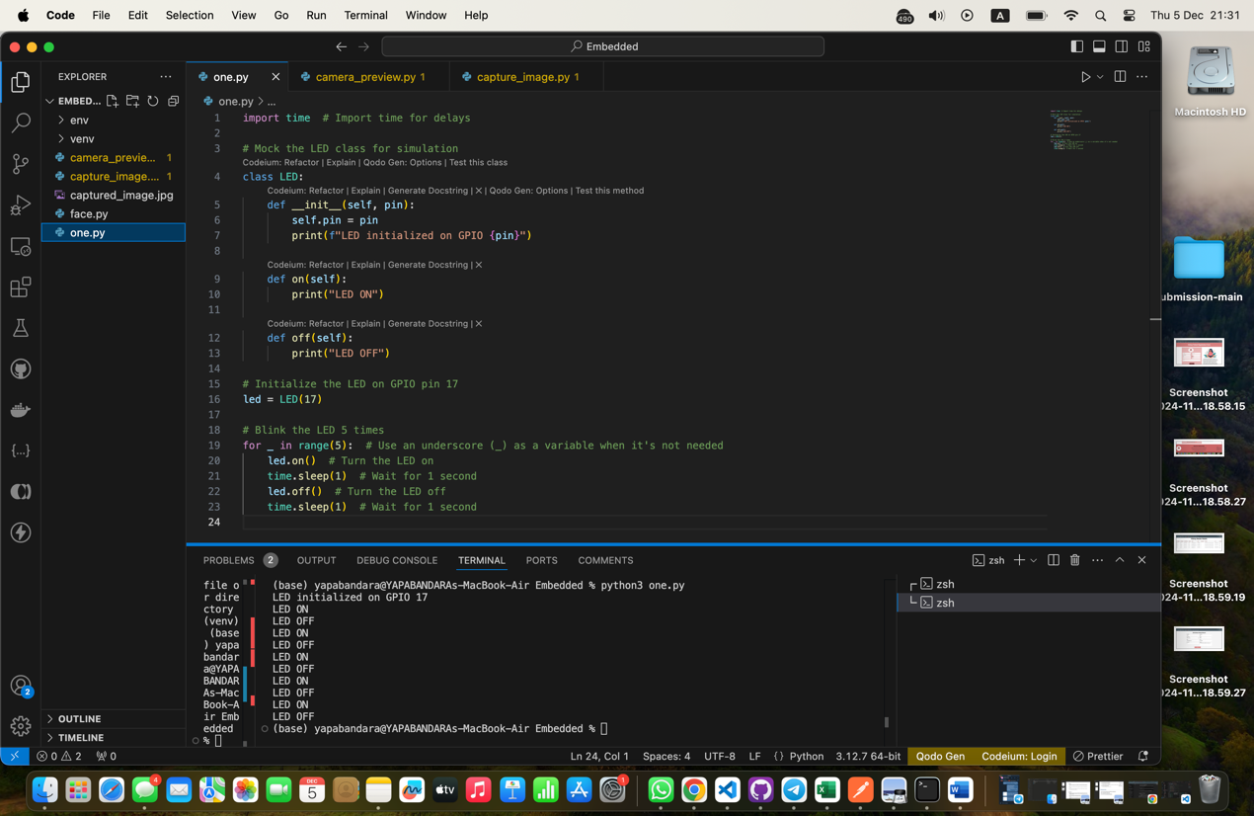**03).**

import time

class LED:

def __init__(self, pin):

self.pin = pin

print(f"LED initialized on GPIO {pin}")

def on(self):

print("LED ON")

def off(self):

print("LED OFF")

led = LED(17)

for _ in range(5):

led.on()

time.sleep(1)

led.off()

time.sleep(1)

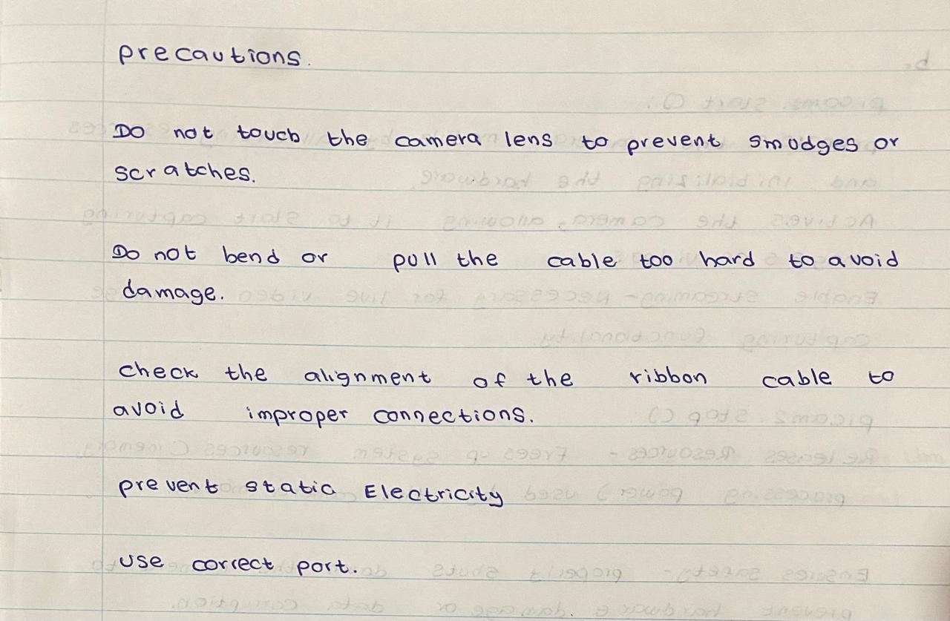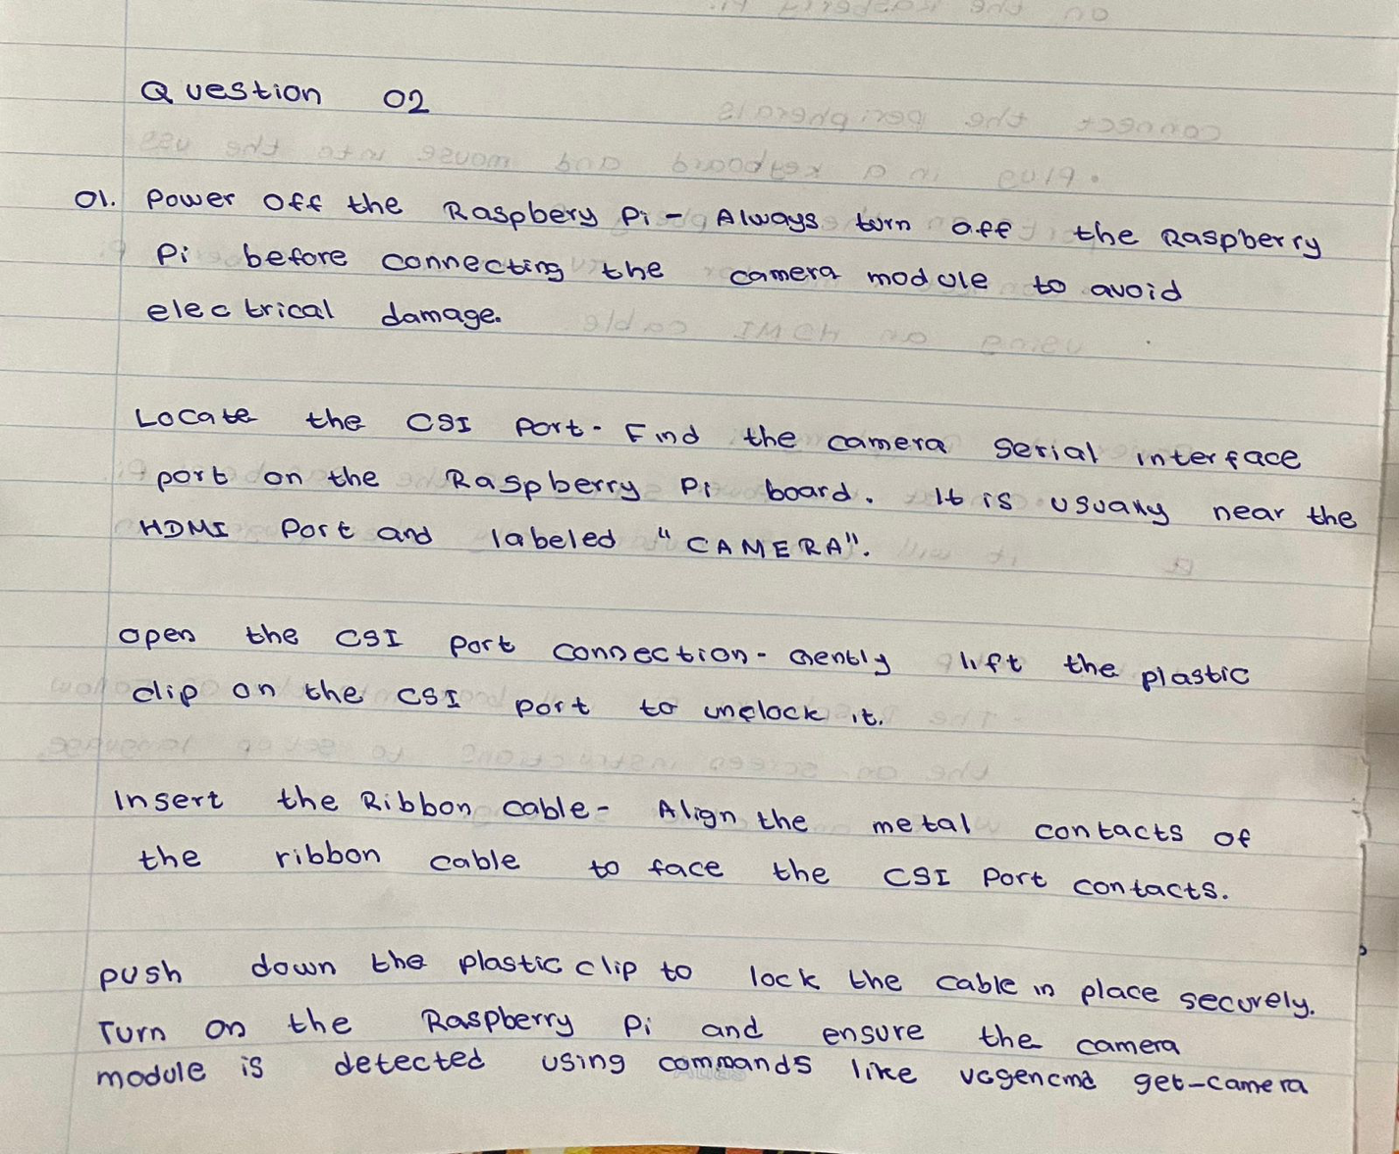**Question 2**

**02)**

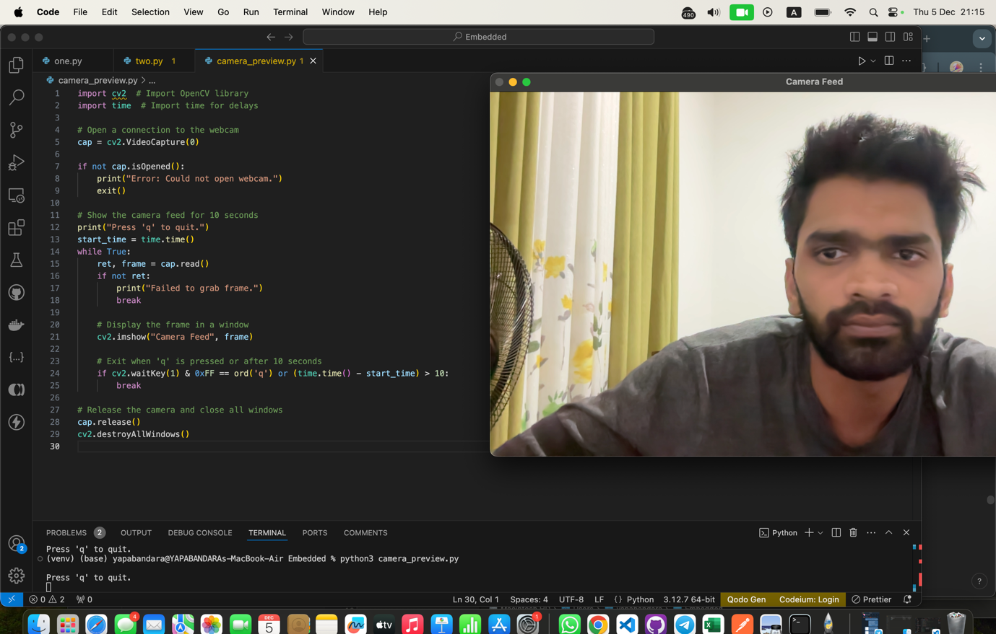

import cv2

import time

cap = cv2.VideoCapture(0)

if not cap.isOpened():

print("Error: Could not open webcam.")

exit()

print("Press 'q' to quit.")

start_time = time.time()

while True:

ret, frame = cap.read()

if not ret:

print("Failed to grab frame.")

break

cv2.imshow("Camera Feed", frame)

if cv2.waitKey(1) & 0xFF == ord('q') or (time.time() - start_time) > 10:

break

cap.release()

cv2.destroyAllWindows()

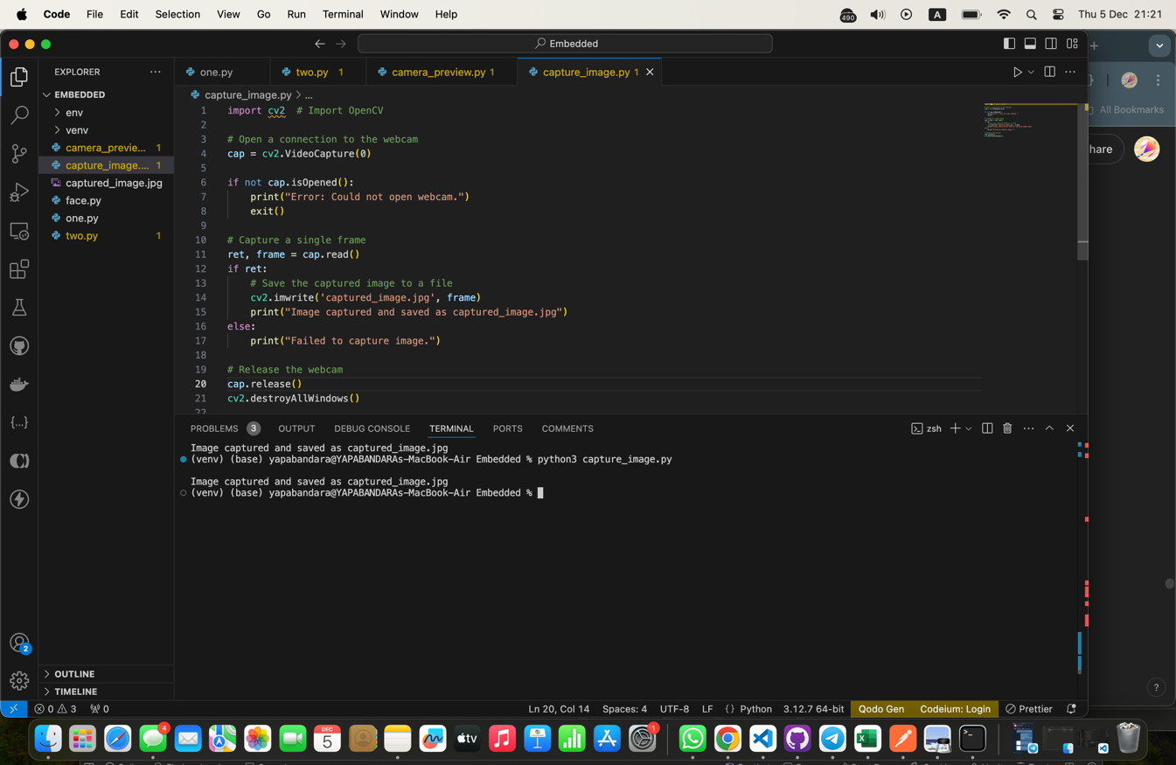**03).**

import cv2 # Import OpenCV

cap = cv2.VideoCapture(0)

if not cap.isOpened():

print("Error: Could not open webcam.")

exit()

ret, frame = cap.read()

if ret:

cv2.imwrite('captured_image.jpg', frame)

print("Image captured and saved as captured_image.jpg")

else:

print("Failed to capture image.")

cap.release()

cv2.destroyAllWindows()

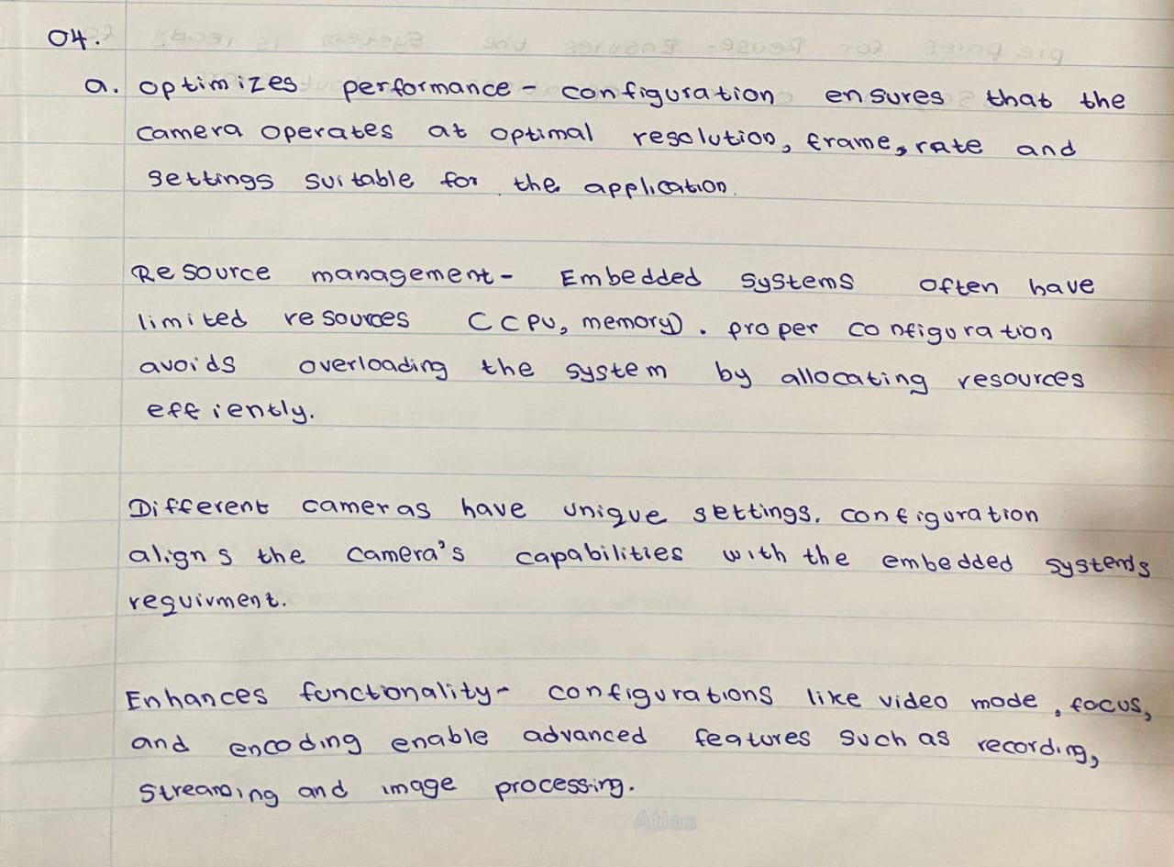

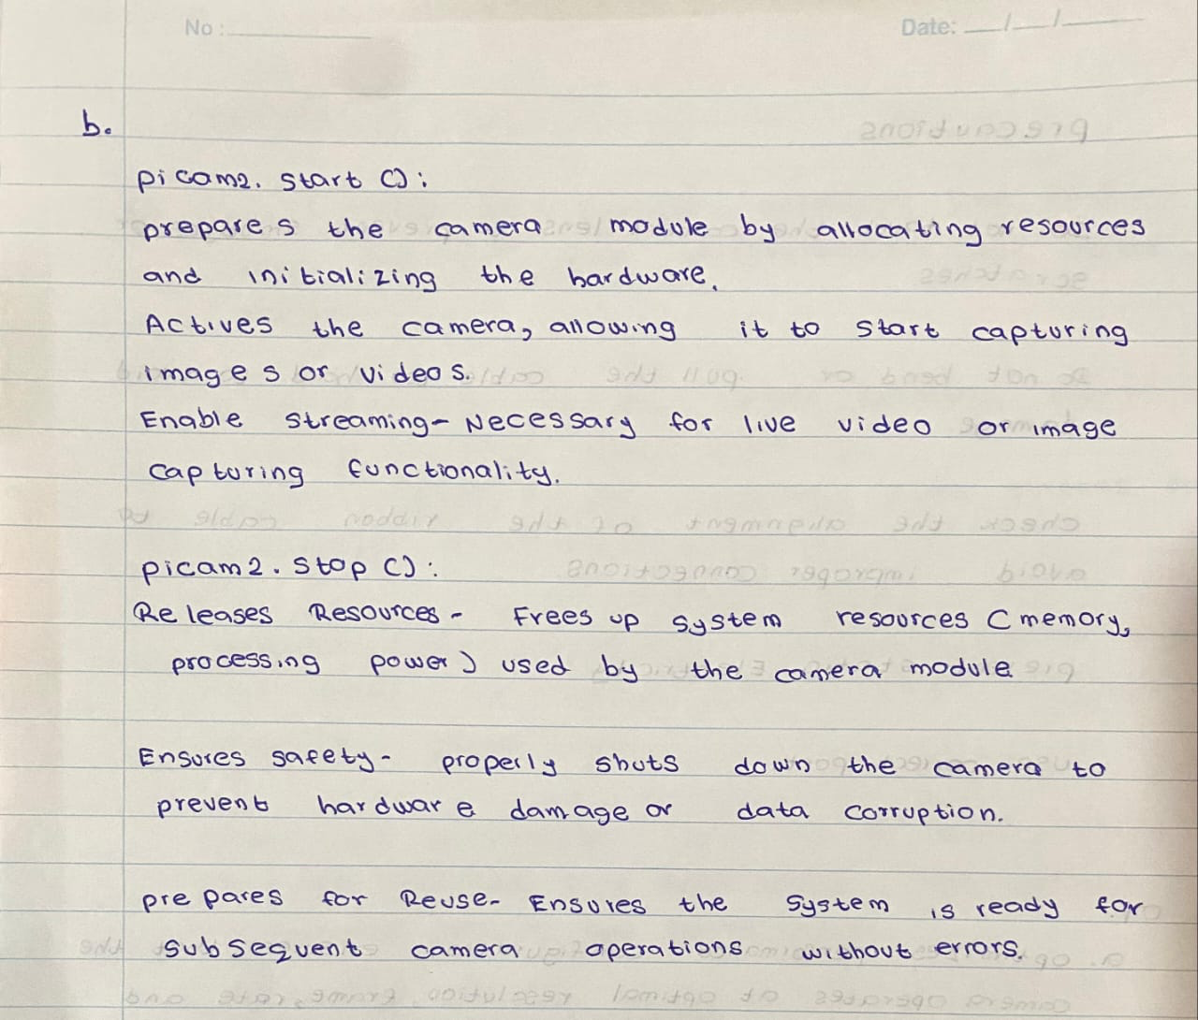

**Question 3**

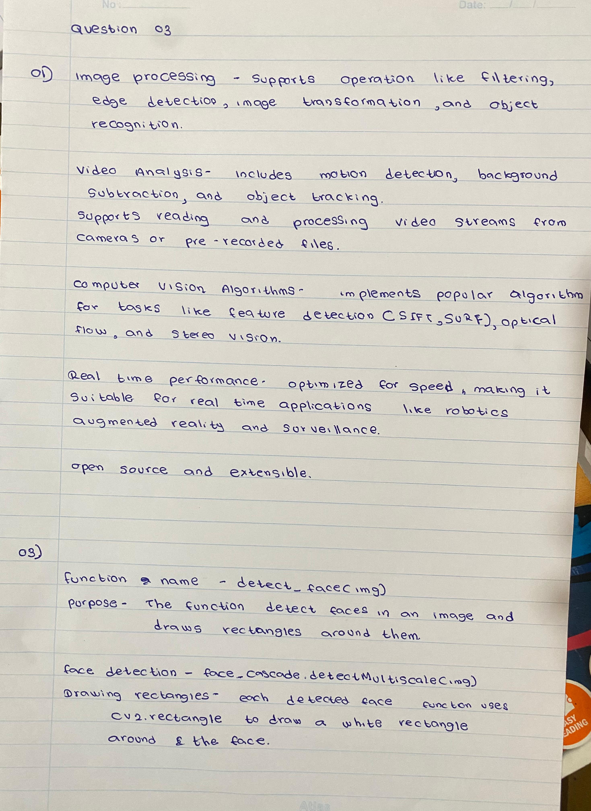

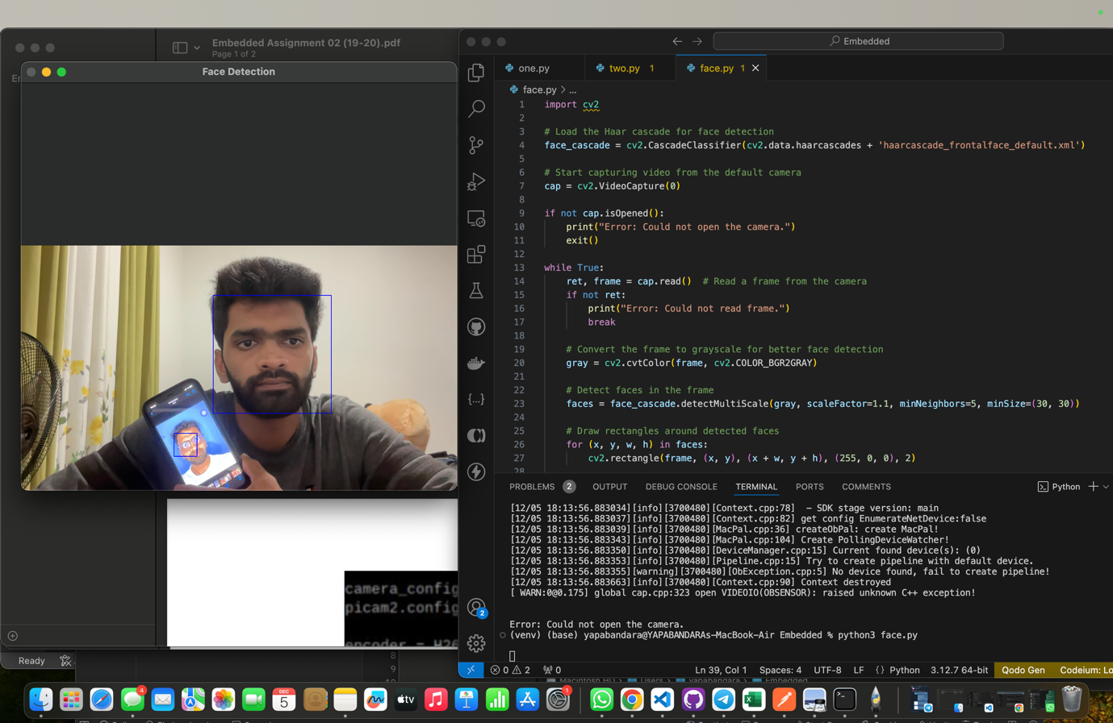**02).**

import cv2 # Import OpenCV

cap = cv2.VideoCapture(0)

if not cap.isOpened():

print("Error: Could not open webcam.")

exit()

ret, frame = cap.read()

if ret:

cv2.imwrite('captured_image.jpg', frame)

print("Image captured and saved as captured_image.jpg")

else:

print("Failed to capture image.")

cap.release()

cv2.destroyAllWindows()